**Group-5**

**Dhruv Patel & Prince Patel**

Project PROPOSAL

**Project Overview**

The Expense Tracker Application is designed to assist users in managing their expenses efficiently. The application will be developed using Visual Studio as the primary Integrated Development Environment (IDE). The main technologies utilized in the development include C#, XAML, and .NET MAUI (Multi-platform App UI). The purpose of the application is to provide users with a simple yet comprehensive tool to track their expenditures, categorize expenses, set budgets, and generate reports for better financial management.

**User Interface Wireframes**

Below are the wireframes for each page of the application:

* **Login Screen**: This screen allows users to enter their credentials to access the application.
* **Dashboard**: Provides an overview of the user's expenses, including charts and graphs.
* **Expense Entry Form**: Users can input details of their expenses here.
* **Expense Categories**: Allows users to manage and categorize their expenses.
* **Budget Setting**: Users can set monthly budgets for different expense categories.
* **Reports**: Generates various reports based on expense data.

**User Interface Wireframes**

Below are the wireframes for each page of the application:

* **Login Screen**: This screen allows users to enter their credentials to access the application.
* **Select Category** : Provides an overview of the user's expenses, including charts and graphs.
* **Grocery Expense Entry Form**: Users can input details of their expenses here.
* **Bill Payments** : Allows users to manage and categorize their Bills .
* **Budget Setting**: Users can set monthly budgets for different expense categories.
* **Reports**: Generates various reports based on expense data.

**Project Responsibilities :-**

**Dhruv Patel :-**

Dhruv Patel took the lead in sketching out the project's initial design, laying the groundwork before diving into the final production stages.

He also tackled the coding and layout for features like Select Category, Bill Payments, and the Calculator. Plus, he wrote the code for the Items class and sourced content for the project's presentation.

**Prince Patel :-**

Prince Patel, on the other hand, focused on crafting the Login Page and the Grocery Manager, ensuring they were both functional and visually appealing. He spearheaded the project proposal and kept it updated as the project progressed.

Additionally, Prince was responsible for creating class diagrams and coding for the BillEntry class. He rounded off his contributions by putting together the project presentation.

**UML Diagram**

This diagram illustrates the relationships between the classes and their respective attributes and methods. Each class is represented with its name, followed by its attributes and methods. The attributes are prefixed with a hyphen (-) to indicate that they are private, and the methods are suffixed with parentheses indicating their invocation.

**Before UML :-**

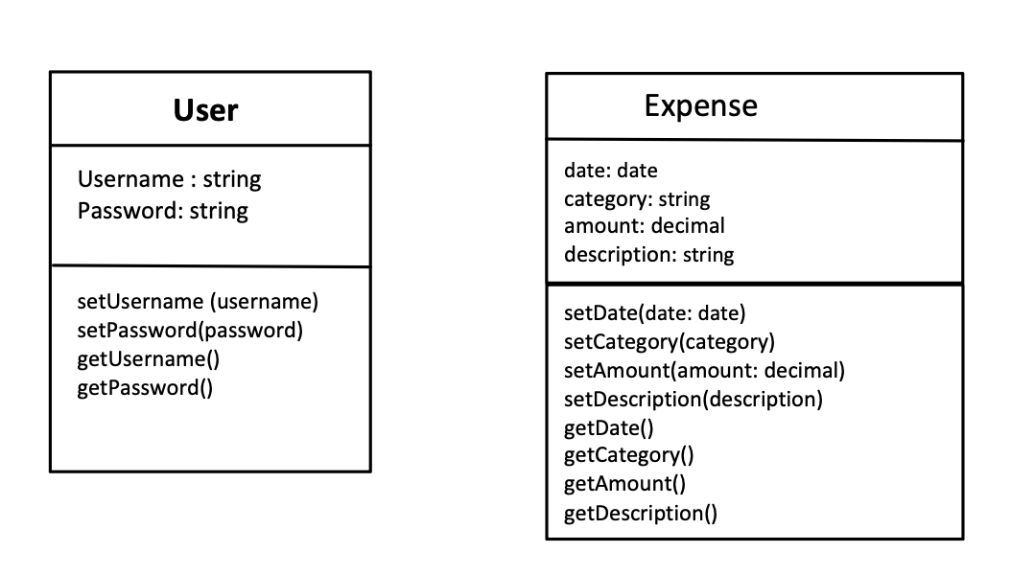

**After UML :-**

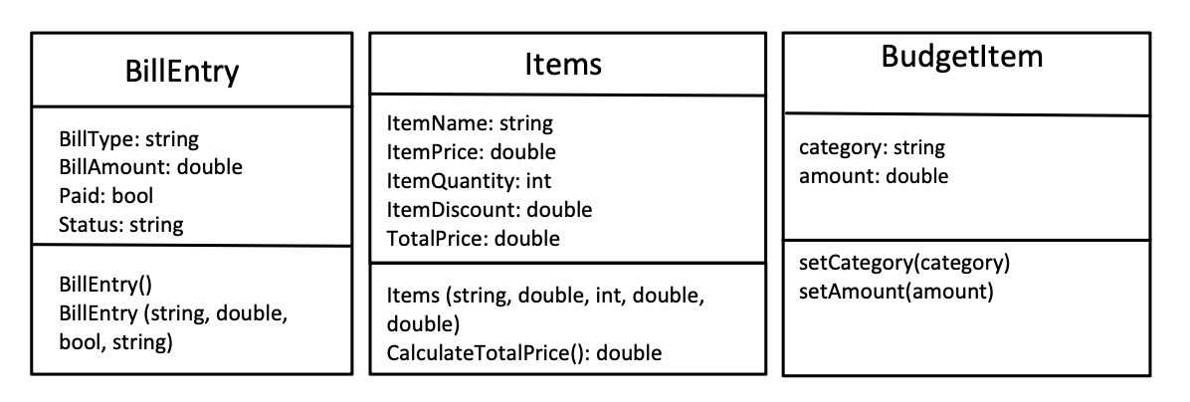

**Data Design**

The application will generate and manage data related to user accounts, expenses, expense categories, and budgets. Example:

* **User Accounts**: Username and password for user authentication.
* **Expenses**: Details such as item name, price, quantity, discount, and total price.
* **Expense Categories**: Categories for organizing expenses, such as groceries, bill payments, etc.
* **Budgets**: Monthly budget allocation for each expense category.

**Before Design:-**

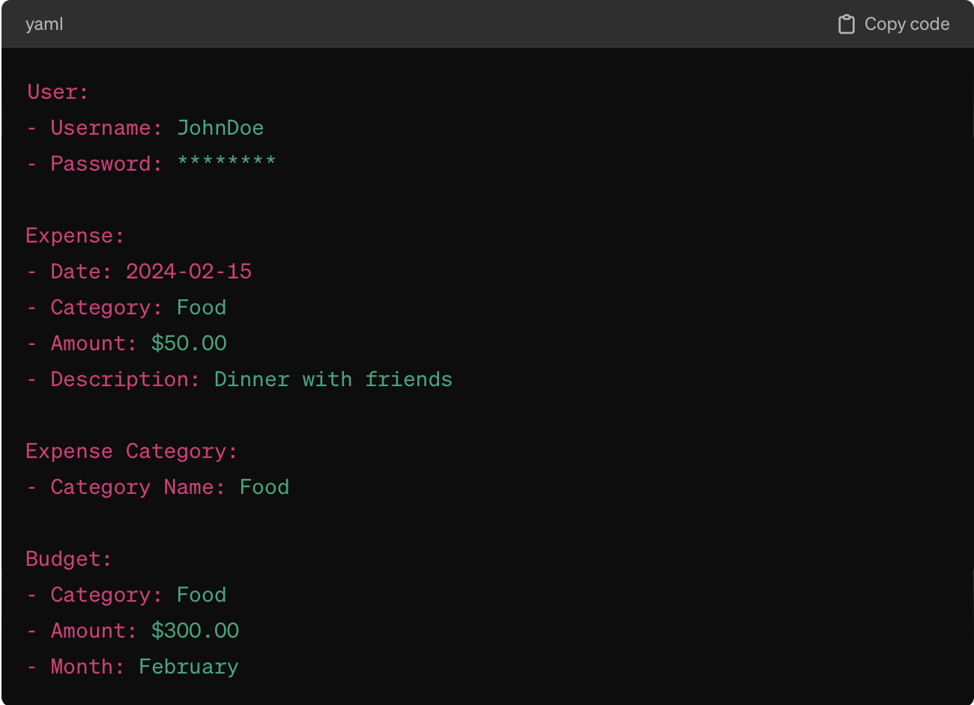

**After Design:-**

